TOWNSVILLE ROAD RUNNERS - TUES NIGHT TRAINING
- COST: $8. Pay directly in the box provided (honesty system). Please mark your name on the attendance register. $3 pays for the track hire and $5 is for the coaching/session.

- These sessions are self-paced and are aimed at assisting you to meet your running goals.

- These sessions are only one small part in your weekly running schedule. By attending, you agree to listen to your body (I only see you once a week) and inform me if you are suffering from any illness or injury at any time.

- If you are new, please introduce yourself to me prior to joining in for the first time. Non members of TRR will be required to fill out a basic pre-exercise screening form prior to your first session so please allow time for this (5 mins).

- The sessions can always be tailored to meet your current running goals. The same session will not suit everyone, so talk to me and let me know what you are training for. An example may be 12 x 400 with 60 sec rest – this session can be adapted numerous ways to cater for beginners, those who want extra speed or those who need strength/endurance. If in doubt – always ask.

- If you don’t do any strength work, then try and incorporate the basic exercises I prescribe at least once a week to try and minimise the risk of running related injuries.

- The warm up is similar each week and includes a 10-12 min jog (self-paced) and then a series of running specific drills. Once you have attended a couple of times you will be expected to go through these drills as part of your normal warm up routine. The run throughs / strides we do to finish each warm up should be slightly faster than the intensity of the interval session about to be undertaken.

- The sessions will be structured around major races on the TRR and NQ area calendar. If you are training for a specific race, let me know and the sessions can be adjusted.
Simon O’Regan
Level one track and field coach
Level one strength and conditioning coach
Diploma of Fitness

TOWNSVILLE ROAD RUNNERS TUES NIGHT SPEED WORK.
WARM UP Routine
- 5.30pm sharp – leave from track clubhouse for 10-12 min group jog. The route is either around the grass oval opposite the track, through the botanical gardens and around the grass oval or around Grammar school and the oval. Always be careful of traffic – the warm up jog should start very slowly and see you running comfortably after approx. 5-6 mins.

- 5.40 – 45 meet on back straight of track and commence these drills.
1. Leg swings – 8 to 10 each leg x 2
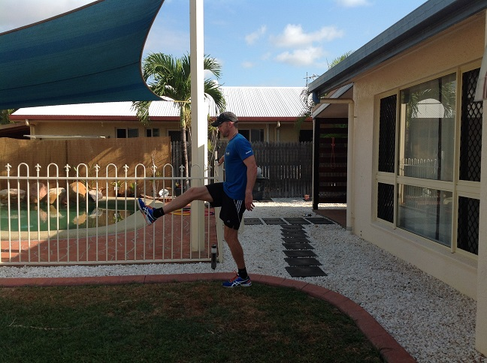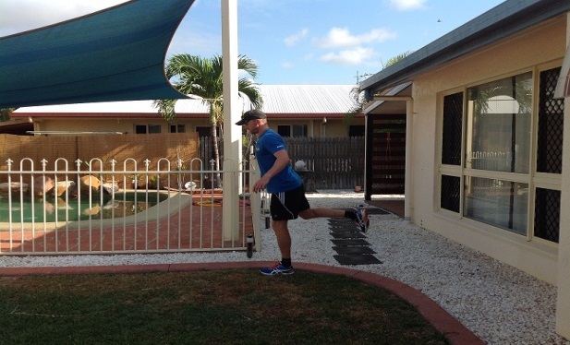
- Balance on 1 leg and do 8-10 easy swings each leg.
- Use glute to control backwards movement – torso remains stable
2. Adductor swings – 8 to 10 each leg x 2.
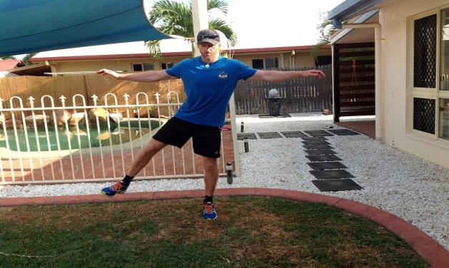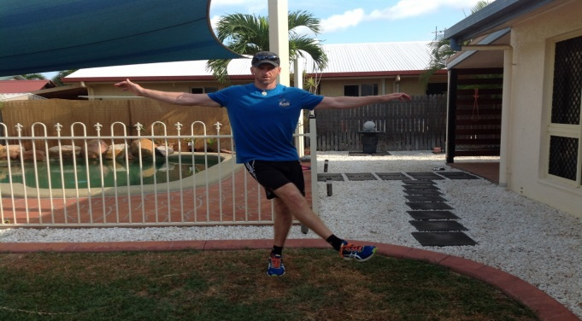
- Balance on 1 leg and do 8-10 easy swing throughs each leg.
- Hold onto fence or post if required.

3. Hip flexor drill – Samson stretch 3-5 sec each leg x 3 to 5.
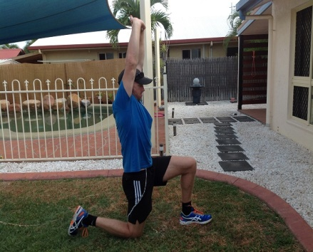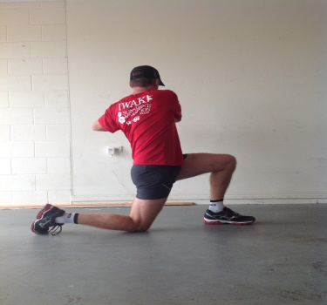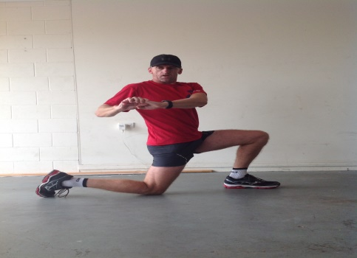
- Establish a lunge position with knee directly under your hip – now elevate shoulders and shrug biceps close to the ears whilst pushing forward at the hip. Start with arms by your side and progress to extension above your head.
- Progress to have your knee slightly off the ground but only if you can hold the exact same posture. Add rotation and hold each side for 3-5 sec once you have mastered the basics.
4. Leg over drill – 8 to 10 each leg.
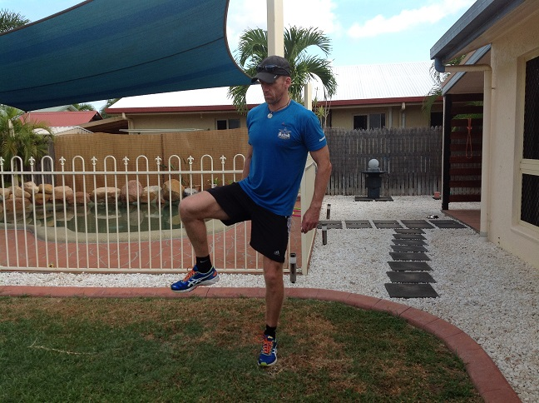
- Walk down the track taking the leg from the side to the front. Step forward and conduct on the other leg.
- Aim to stabilise on supporting leg and keep pelvis stable towards the front.
5. Heel kick/knee drive drills every 2nd or 3rd step down the track for 50-60m.
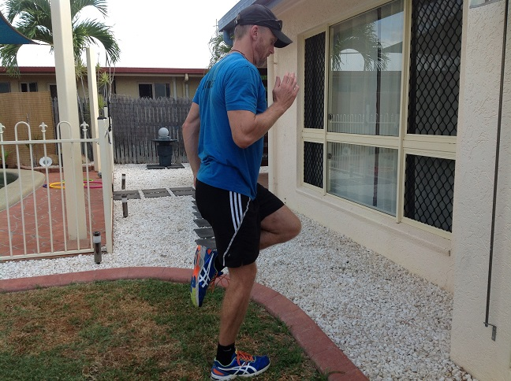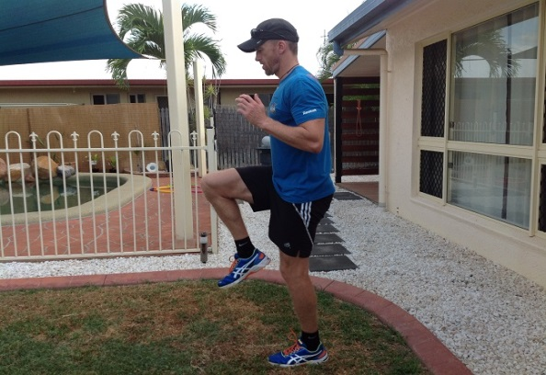
- Aim for normal running posture – tall and use your arms.
- One foot remains on the ground whilst the other dynamically pulls directly up towards to glute. Run a couple more steps and change legs.

6. Calf pump drill.
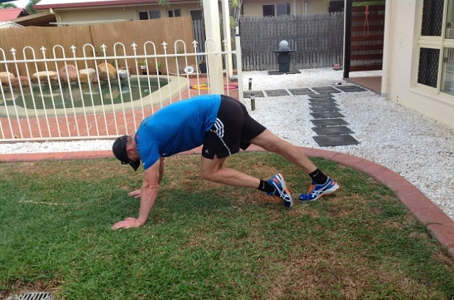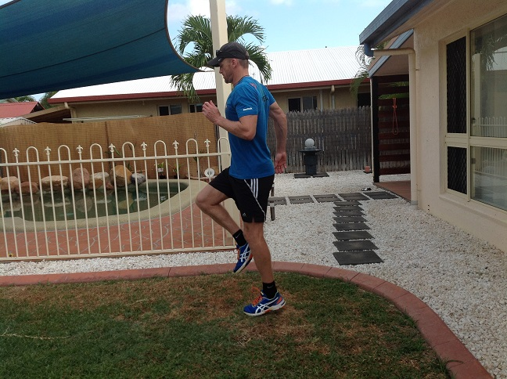
- In push up position with hands directly under the shoulders – run on the spot through your toes aiming for full range through your big toe joint and the heel gently touching the ground each time – 20 reps total.
- Come out of that and do 10m of ‘cool walk’ where you skip with the aim of pushing off through your calves.
- Repeat twice.
7. Leg out and squat drill.
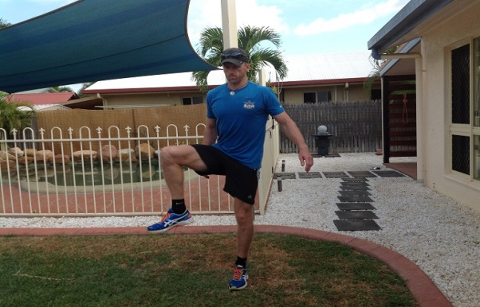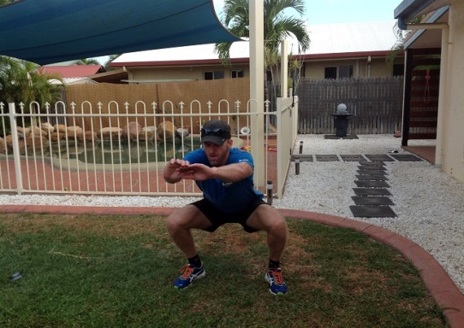
- Start with raising leg to 90 degree at knee and then pass from in front of the body to the side. Finish with feet shoulder width apart and conduct a controlled squat aiming at breaking at the hips, weight in the heels and chest up. Repeat other side. 6-10 total
8. Run through. 10 – 20 m of high knees and then 80 m run through. Aim for fast, smooth and relaxed at designated pace. Quick leg turn over.
9. Tip and reach x 3 to 5 each leg.
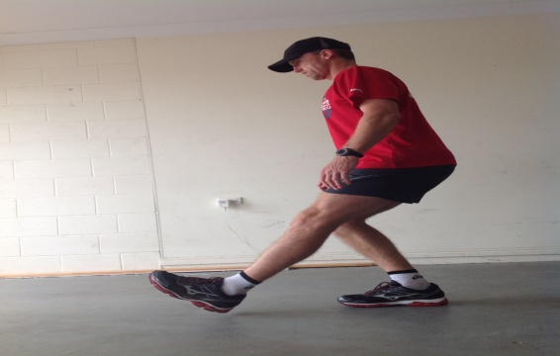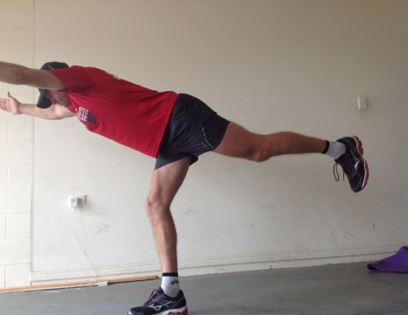
- Single leg squat – aim to break at the hips first. Place one leg out in front of the body and sit back until the heel of the front leg touches the ground.
- Reach - now bend from the hips aiming to keep your normal lumbar curve and reach to the front aiming for extension through the spine. You should feel a good stretch through the hamstring of the supporting leg whilst also working on balance.
10. Knee drive and glute stretch
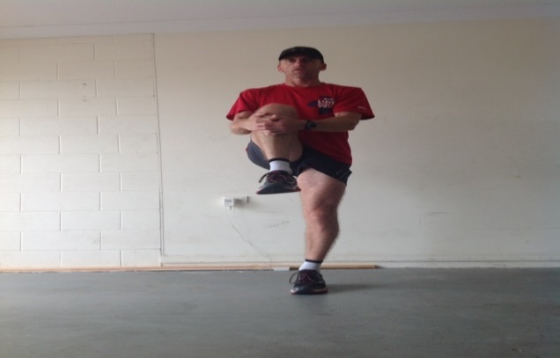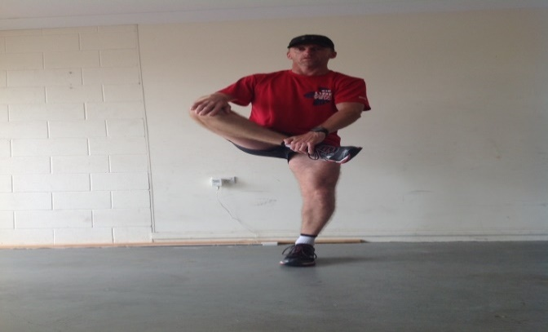
- Pull the leg to your front whilst keeping a tall posture. Do this 3-5 times each leg and then place one hand on the ankle and one at the knee and pull the ankle across the midline and aim to hold for 1-2 seconds. Repeat 3-5 times each leg.
11. 80 m run through. Build pace now to the pace expected for the first repeat for the session.
12. Hamstring stretch x 4-8 each leg or spend time on an area that you are generally tight.
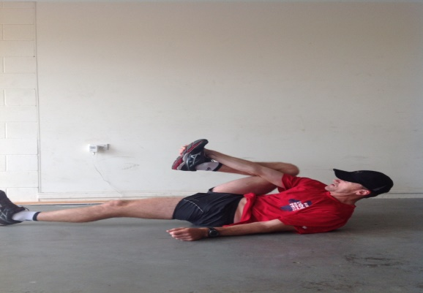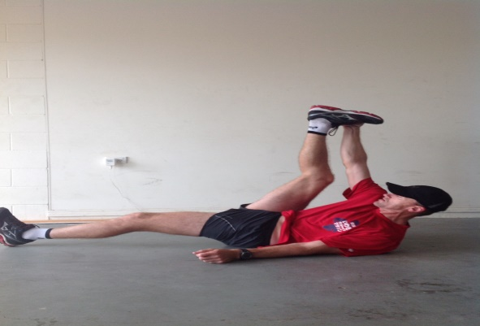
- Place hand on the outside of your foot with the arm running on the inside of the knee. Extend and bend slowly. If unable to get into this position you can grab behind the knee and do the same drill and or repeat the legs swings from above.
13. 60-80 m run through at 1500m – 3km pace. Rest 15-20 sec whilst you walk around the bend and repeat with one rep at faster than the pace for the first rep.
13. Session brief.
14. Commence session – usually around 6pm.
15. Finish with 5 mins core or run specific strength training (set by Simon or your own exercises prescribed by a health professional) followed by self-paced stretching. If you are tight and or sore and you don’t know how to stretch – please ask.
Strength work
- In the coming pages is a section of running specific exercises aimed at keeping the required strength to minimise your risk of injury.
- If you do not currently do these types of exercises then start with once per week for a 2-4 week period. If you have minimal soreness after two weeks, start to add another session in.
- Most of you will benefit from doing these exercises 2- 3 days per week.
- You will find easier and harder versions of these exercises that work the same muscle groups – always master the easy exercise before you attempt the harder version.
- Remember that stretching and mobility work (foam rolling, trigger point with tennis balls etc) play a key part in keeping you supple. Running by its very nature shortens muscles and makes tendons stiff so be sure to take at least 5-10 mins a few times each week to include this as part of your training. I have also included basic examples to get you started in this area.
- Upper body work – body weight exercises including push ups and pull ups are an effective method of maintaining some strength for your upper body. A word of caution – if running faster is your goal, extra muscle mass may be detrimental. Having said that, it may also be advantageous for weight loss and other areas.

Running - strength exercises.

Be proficient at a squat before you start lunging
Rearward Lunge L 1 (start with rear lunge and if able to hold balance and form progress to lunge walking. 12-15 steps each leg, rest 30-60 sec x 2-3 times.

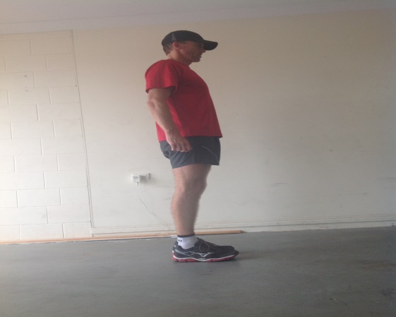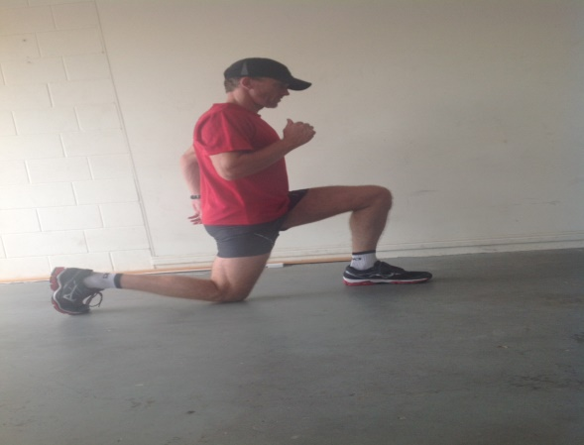

(1) Start in standing position, feet shoulder width apart.
(2) One leg at a time step rearward – aim to keep torso upright, knees at 90 degrees.
(3) Avoid rear near smashing into the floor. Keep weight in heel of front leg.
(4) Return rear leg to standing position and swap legs and repeat.
(5) Progress to forward lunge, but ensure the front knee does not drive forward – keep the heel on the ground.

Single Leg Calf Raise – Supported – progress to unsupported (start double leg if required)

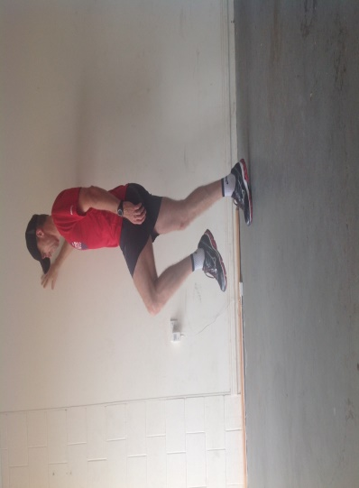

(1) Stand on one leg and supported by wall.
(2) Raise onto toes (calf flexion) and lower back down using the one leg only. 20+ reps / 30 sec rest x 3 sets. Start with isometric holds 30-50 sec.

Balance – Tip and reach as per running warm up

Bridge Static Hold L 1 - below are numerous options pending your ability to keep sound posture throughout. Do not move to the more complicated exercise until you can achieve the time/reps with good form.

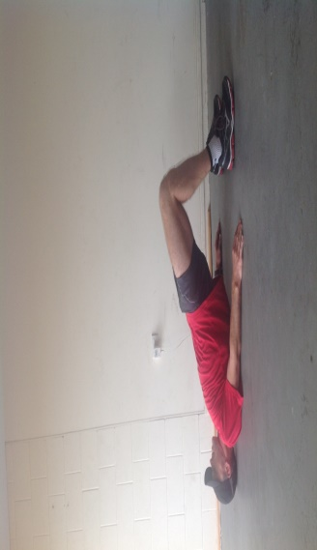

- Lay down with arms beside the body, legs at 90 degrees
- Raise hips up into extension until a straight line runs through the body – Load through heels.
- Lock the core to maintain hold and breath. Hold for 5 sec and lower down to rest – 12-15 reps x 2 sets.

Bridge Pump L 2

(1) Lay down with arms beside the body, legs at 90 degrees
(2) Lock the core, raise hips up into extension then lower down – 2 sec up, 2 sec down.
(3) Continue the up / down movement (pump) for 12-15 reps / 30 sec rest x 3 sets.

One Leg Bridge Hold L 3

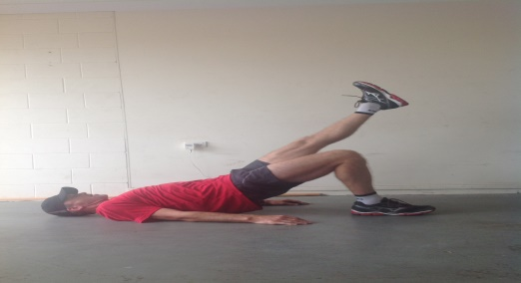

(1) Lay down with arms beside the body, legs at 90 degrees
(2) Raise hips into extension and then extend one leg, hold for 5 seconds
(3) Lower leg, then lower hips to floor. Swap legs x 12-15 reps x 2 sets

One Leg Bridge Pump L 4

(1) Lay down with arms beside the body, legs at 90 degrees.
(2) Extend one leg forwards until thighs run parallel.
(3) Lock the core, raise hips into extension, lower and repeat – 2 sec up, 2 sec down. 12-15 reps / 30 sec rest x 3 sets.

Bird Dog Single Arm Raise L 1

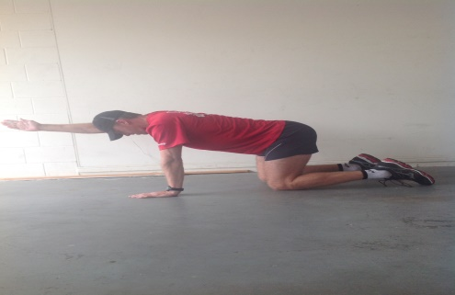

(1) Four point kneeling position – straight line from head to hips.
(2) Slow contract your abdominals – pull belly button towards lower back.
(3) Raise and extend one arm and hold up for up to 3 seconds, lower back down and swap arms. 12-15 reps / 30 sec rest x 3 sets.

Bird Dog Single Leg Raise L 2

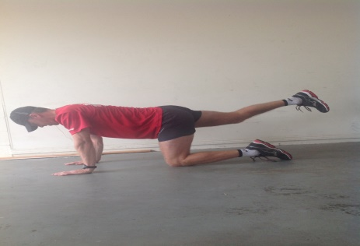

(1) Four point kneeling position – straight line from head to hips.
(2) Slow contract your abdominals – pull belly button towards lower back, lift leg with the glutes.
(3) Raise and extend one leg and hold up for up to 3 seconds, lower back down and swap arms. 12-15 reps / 30 sec rest x 3 sets.

Bird Dog Alternate Arm/Leg Raise L 3
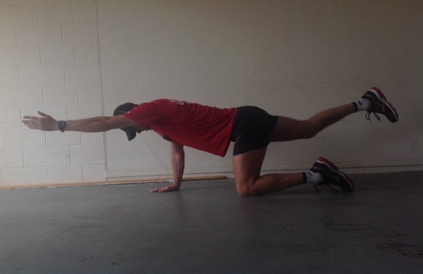

(1) Four point kneeling position – straight line from head to hips.
(2) Slow contract your abdominals – pull belly button towards lower back.
(3) Raise one arm and opposite leg and hold up for up to 3 seconds, lower back down and swap limbs. 12-15 reps / 30 sec rest x 3 sets.

Side Plank
L 1 L 2
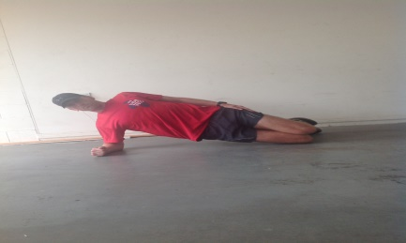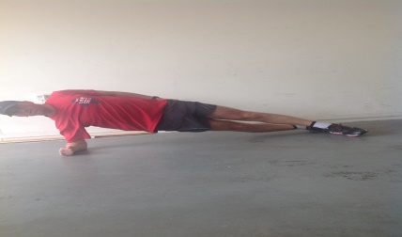

(1) Lie on side with one arm supporting under the shoulder and one foot placed behind the other.
(2) Raise the hips off the floor until body forms a straight line with natural spinal alignment.
(3) Rotate shoulder in and down to ‘turn on’ lats during this exercise. Elbow should be directly under the shoulder. 15-30 sec x 3 (rest as required)

Front Plank L 1

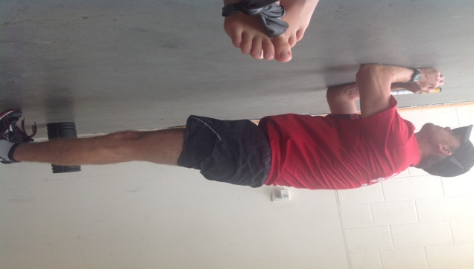

(1) Lie on the floor with feet shoulder width apart and forearms resting on the floor directly under the shoulders.
(2) Raise hips up until a straight line is formed from ankles through to head
(3) Use a broom handle to assist (touching – glutes-shoulder blades-head) – build up to 1 minute with good form x 2-3 times.

Front Plank with Rotation L 2

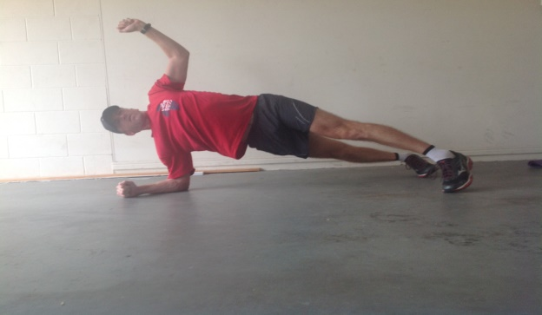

(1) Conduct a front plank
(2) Whilst maintaining a locked core / spinal alignment rotate the body to one side
(3) Rotate through ROM and then lower back down to the front plank position – hold 3-5 sec in each plane and aim for 3 times through. Rest 30 sec and repeat 2-3 times.
Clam
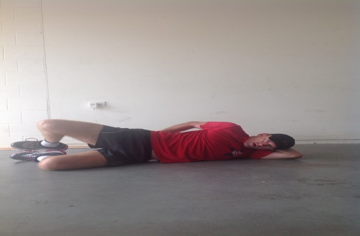

(1) Lie on your side with hips and shoulders in a straight line and bend the knees
(2) Stack your hips directly on top of each other vertically. Do the same with your shoulders.
(3) Keep your toes/heels together as you slowly rotate your leg in the hip socket so that the top knee opens.
(4) Only open the knee as far as you can without disturbing the alignment of your hips. Lower the knee back down. Progression can be for this exercise to be done in the side plank position. 15-20 reps each side 2-3 times.

Monster Walks – with Band
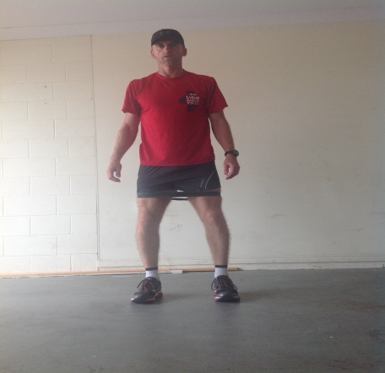

(1) Utilising a Thera Band of suitable length / tension, place above knees / or above ankles as a variation
(2) Slowly step laterally (to the side) 15-20 steps or until fatigue.

Core and mobility exercise ideas (Pictures only) – if unsure, please ask.
- There are also several core exercises from the strength work above that can be utilised.
- Ensure you work the lower back with bridging and planks and not just the abbs.
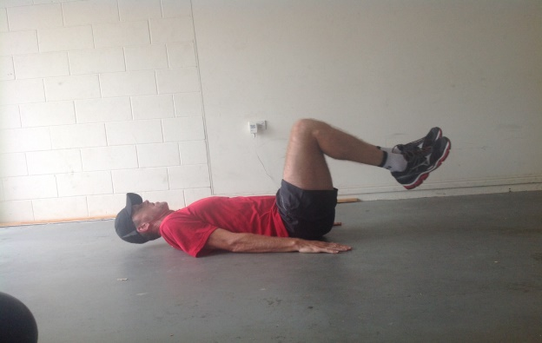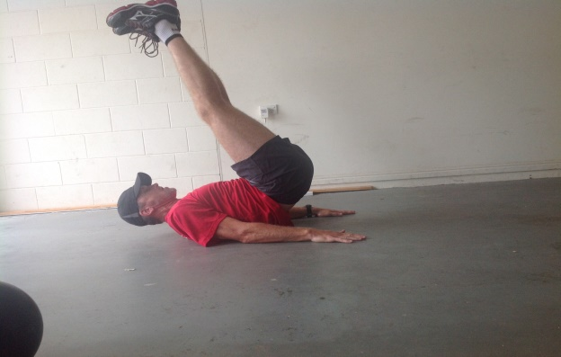
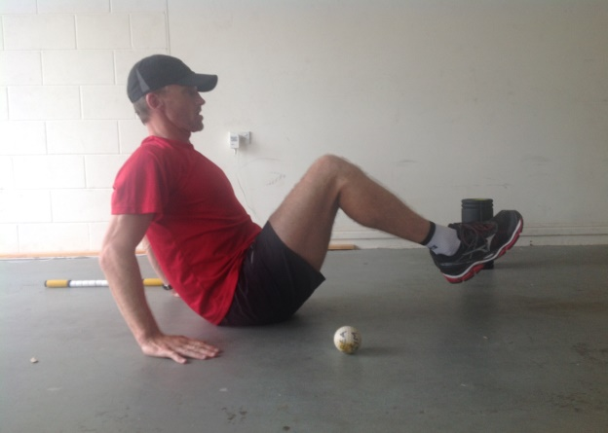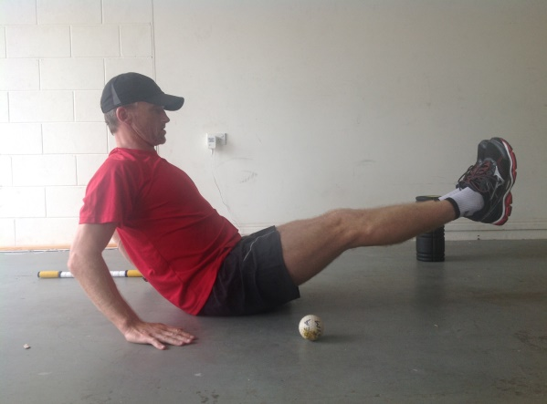
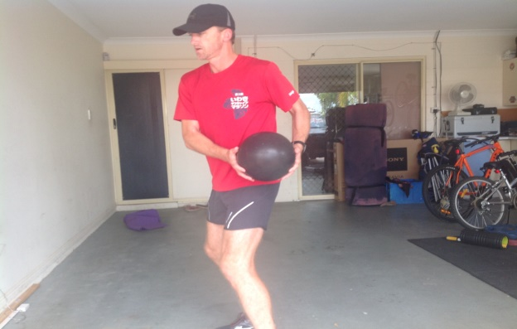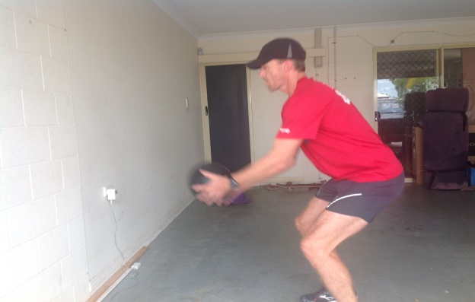

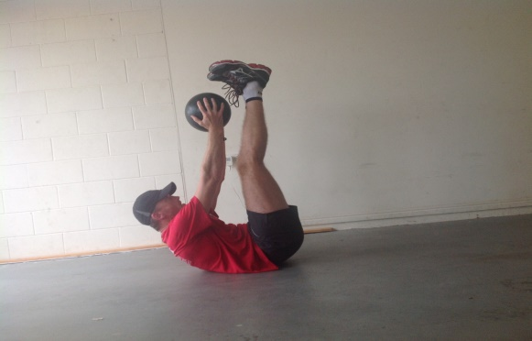
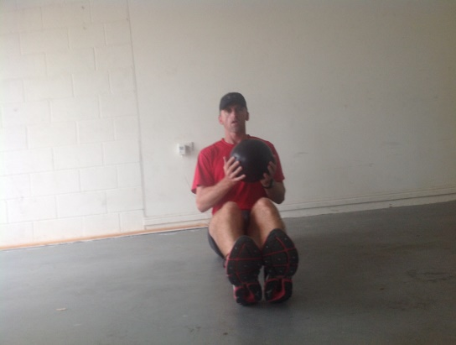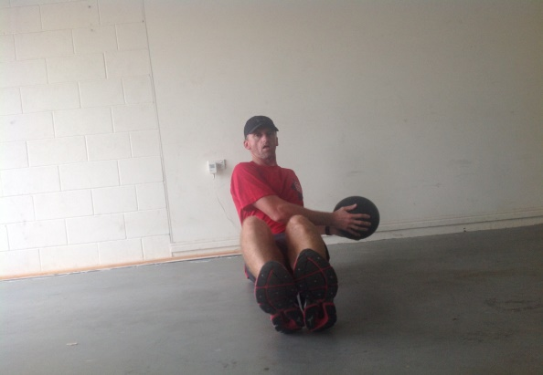

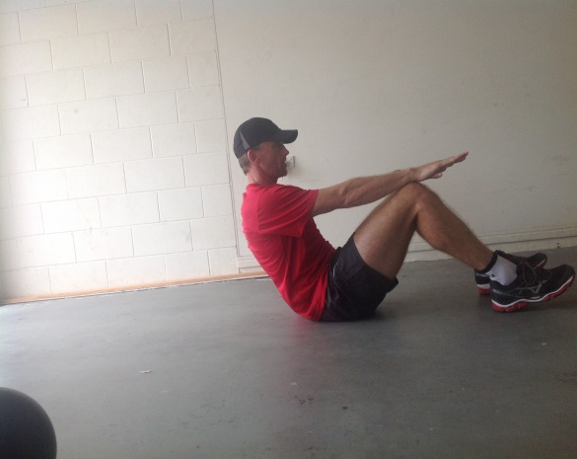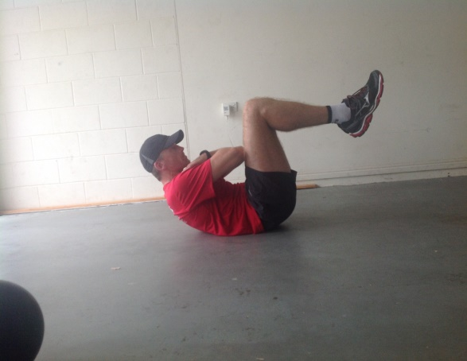
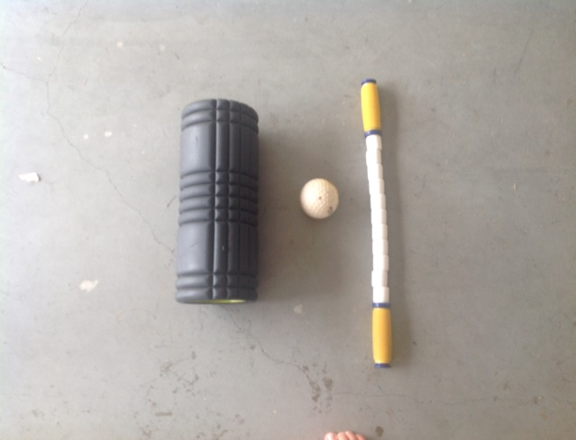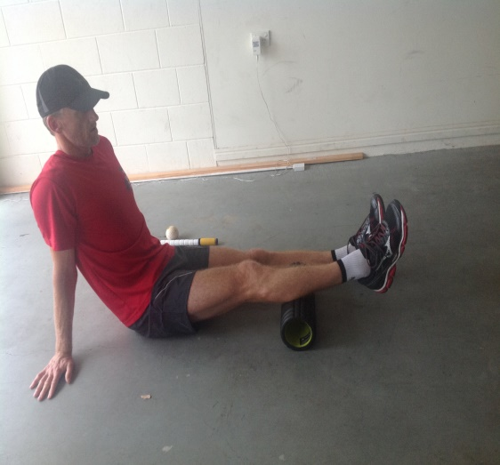
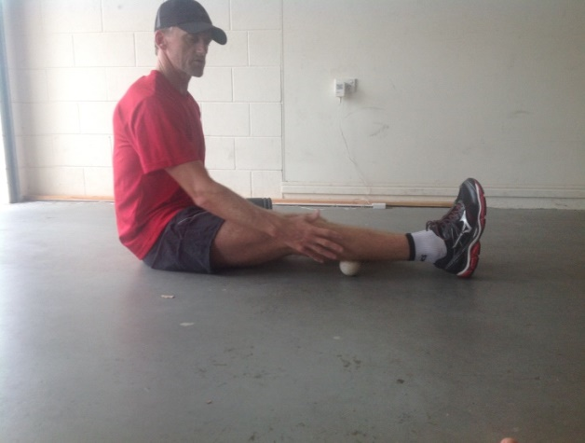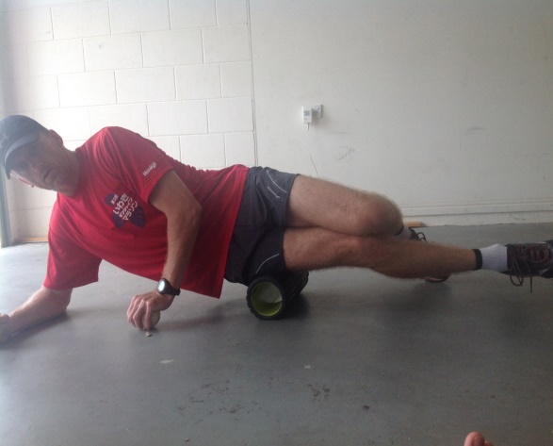

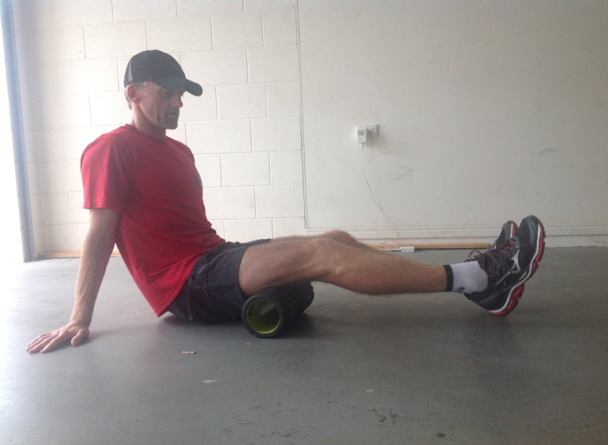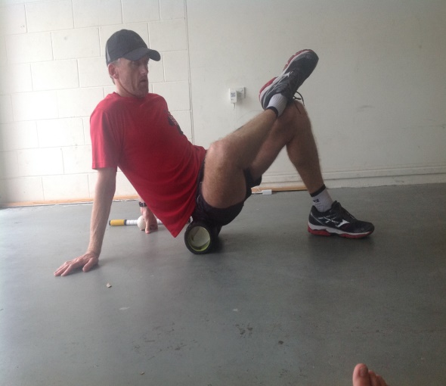
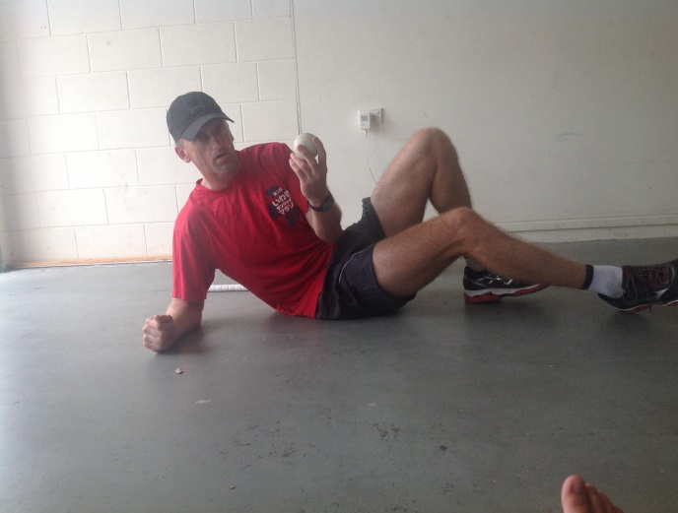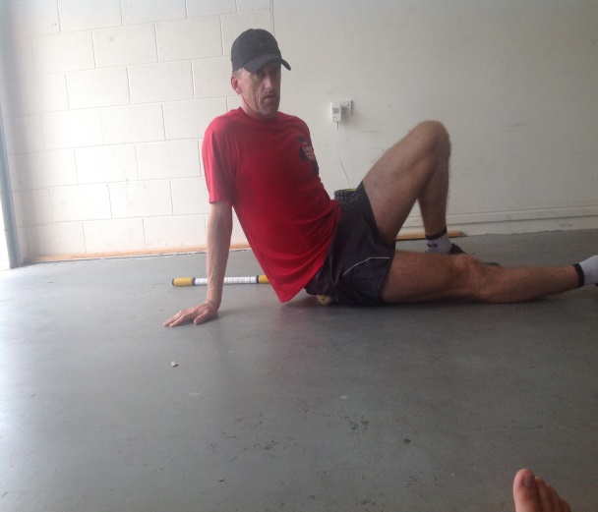
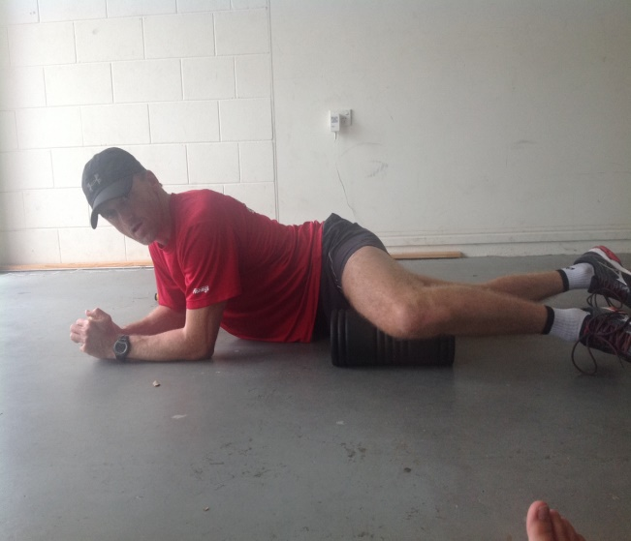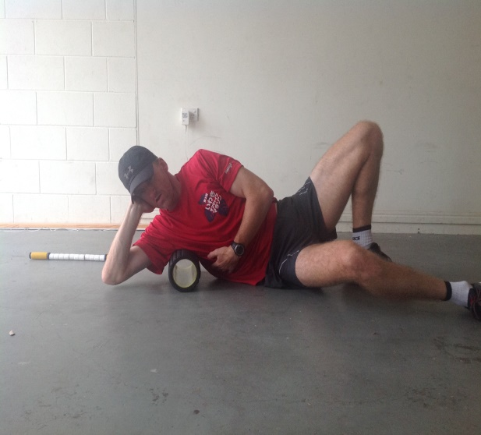

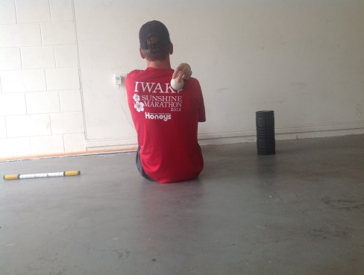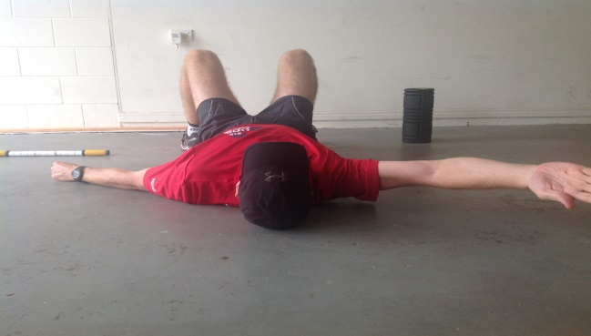
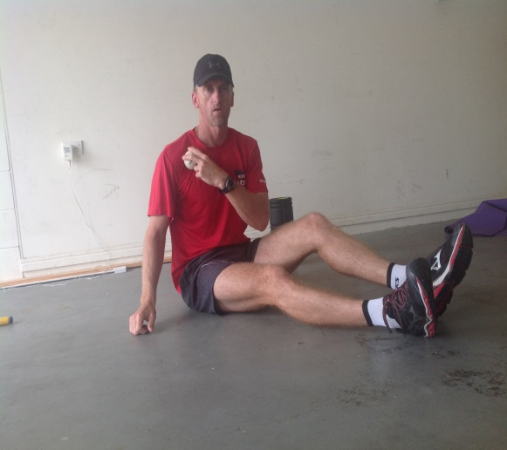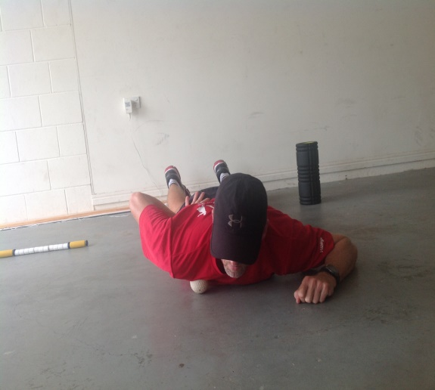

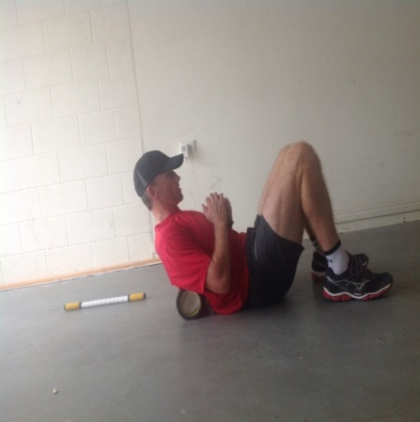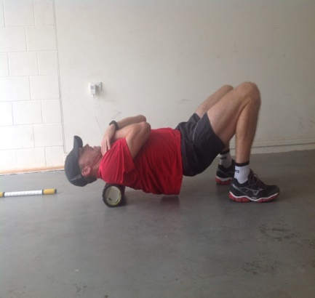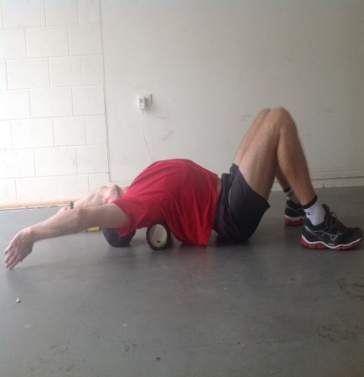
- Caution – only extend over the roller through the upper back. Never do this with the roller under the lower back.

